**Table 1: Balance Table (Q2)**

|  |  |  |  |
| --- | --- | --- | --- |
|  | Control | Treatment | Difference |
| Academic Quality | 0.515 | 0.466 | 0.049 |
| Athletic Quality | 0.424 | 0.551 | -0.127** |
| Near Big Market | 0.360 | 0.700 | -0.340*** |

* p<0.1, ** p<0.05, *** p<0.01

**Notes:** Here we see that between the control and treatment there are differences in the means, which means that those who were “ranked in 2017” were different in two of the covariates of interest. This ultimately means that the test fails for balance between the observables (or the covariates) as the two out of three covariates we would have liked to balance are significantly different.

**Table 2: Effect of Covariates on “In-Ranking” of College in 2017 (Q4)**

|  |  |
| --- | --- |
|  | In Ranking in 2017 |
| Academic Quality | -.183 |
|  | (.161) |
| Athletic Quality | .412** |
|  | (.163) |
| Near Big Market | .356*** |
|  | (.0927) |
| Observations | 100 |
| *R*2 | 0.182 |

Standard errors in parentheses

* p<0.1, ** p<0.05, *** p<0.01

**Notes:** Here we see that academic quality did not have a significant effect on whether a college would be “in-ranking” or not in 2017. However, the athletic quality of the college and whether it was close to a big market both had very significant effects on whether the college would be “in-ranking” in 2017.

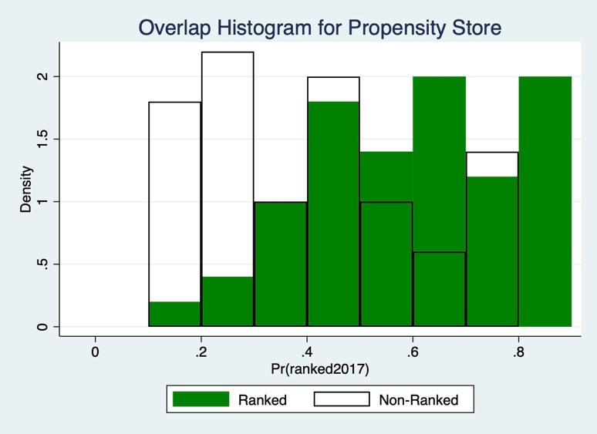**Figure 1:** **Overlap Histogram for Propensity Score by Ranked/Non-Ranked (Q5)**

**Notes:** Based on the overlap histogram it would be wise to take out propensity scores between 0 to 0.3 and between 0.8 to 1 as the overlap is very low in these regions. Otherwise, there seems to be a good amount of overlap to be able to keep.

**Table 3: Regression with Controlled Variables (Q7)**

|  |  |
| --- | --- |
|  | Alumni Donations in 2018 |
| In Ranking in 2017 | 501*** |
|  | (.266) |
| Academic Quality | 105*** |
|  | (2.36) |
| Athletic Quality | 40.4*** |
|  | (5.18) |
| Near Big Market | 992*** |
|  | (4.22) |
| Observations | 67 |
| *R*2 | 1.000 |

Standard errors in parentheses

* p<0.1, ** p<0.05, *** p<0.01

**Notes:** Here we have controlled for the athletic and academic quality as well as its closeness to big cities. Also, we have controlled for fixed effect of the blocks (made by the propensity scores). Furthermore, based on the histogram in Figure 1, I have dropped any observation that was under the propensity score of 0.3 and above 0.8.

After controlling for the fixed effects of all the covariates and blocks, we see that the ranking in 2017 is very significant and increases the alumni donation in 2018 by 501.